LAB # 4:

Name : Muhammad usama

Roll no: 17f_8195:

Section: B

Task 1:

#include<iostream>

using namespace std;

int main()

{

int **ptr=NULL;

int **ptr1=NULL;

int **sum=NULL;

int sr=0,sc=0;

cout<<"eneter the size of row : ";

cin>>sr;

cout<<"enter the size of columns : ";

cin>>sc;

ptr=new int*[sr];

for(int i=0; i<sr; i++)

{

ptr[i]=new int[sc];

}

sum=new int*[sr];

for(int i=0; i<sr; i++)

{

sum[i]=new int[sc];

}

ptr1=new int*[sr];

for(int i=0; i<sr; i++)

{

ptr1[i]=new int[sc];

}

cout<<"enetr the elements of 1 matrix"<<endl;

cout<<endl;

for(int i=0; i<sr; i++)

{

for(int j=0; j<sc; j++)

{

cout<<"enter "<<j+1<<" element of row : "<<i+1<<endl;

cin>>*(*(ptr+i)+j);

}

}

cout<<"enetr the elements of 2 matrix"<<endl;

cout<<endl;

for(int i=0; i<sr; i++)

{

for(int j=0; j<sc; j++)

{

cout<<"enter "<<j+1<<" element of row : "<<i+1<<endl;

cin>>*(*(ptr1+i)+j);

}

}

cout<<"you enter 1st matrix that is "<<endl;

for(int i=0; i<sr; i++)

{

for(int j=0; j<sc; j++)

{

cout<<*(*(ptr+i)+j)<<" ";

}

cout<<endl;

}

cout<<"you enter 2nd matrix that is "<<endl;

for(int i=0; i<sr; i++)

{

for(int j=0; j<sc; j++)

{

cout<<*(*(ptr1+i)+j)<<" ";

}

cout<<endl;

}

for(int i=0; i<sr; i++)

{

for(int j=0; j<sc; j++)

{

*(*(sum+i)+j)=*(*(ptr+i)+j)+*(*(ptr1+i)+j);

}

cout<<endl;

}

cout<<"sum of above matrix is "<<endl;

for(int i=0; i<sr; i++)

{

for(int j=0; j<sc; j++)

{

cout<<*(*(sum+i)+j)<<" ";

}

cout<<endl;

}

for(int i=0; i<sr; i++)

{

delete []ptr[i];

}

delete []ptr;

ptr=NULL;

for(int i=0; i<sr; i++)

{

delete []ptr1[i];

}

delete []ptr;

ptr=NULL;

for(int i=0; i<sr; i++)

{

delete []sum[i];

}

delete []sum;

sum=NULL;

system("pause");

return 0;

}

Result:

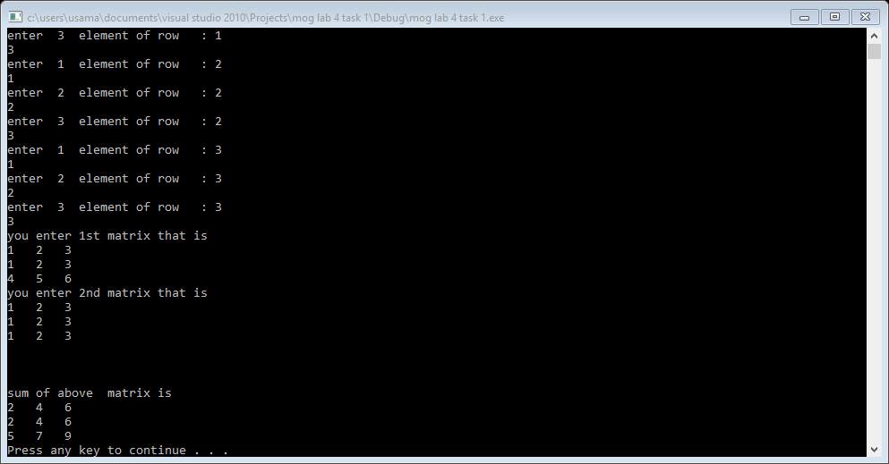

Task 2:

#include<iostream>

using namespace std;

int main()

{

int **ptr=NULL;

int **t=NULL;

int sr=0,sc=0;

cout<<"eneter the size of row : ";

cin>>sr;

cout<<"enter the size of columns : ";

cin>>sc;

ptr=new int*[sr];

for(int i=0; i<sr; i++)

{

ptr[i]=new int[sc];

}

t=new int*[sc];

for(int i=0; i<sc; i++)

{

t[i]=new int[sr];

}

cout<<"enetr the elements of matrix"<<endl;

cout<<endl;

for(int i=0; i<sr; i++)

{

for(int j=0; j<sc; j++)

{

cout<<"enter "<<j+1<<" element of row : "<<i+1<<endl;

cin>>*(*(ptr+i)+j);

}

}

cout<<"you enter this matrix "<<endl;

cout<<endl;

for(int i=0; i<sr; i++)

{

for(int j=0; j<sc; j++)

{

cout<<*(*(ptr+i)+j)<<" ";

}

cout<<endl;

}

for(int i=0; i<sr; i++)

{

for(int j=0; j<sc; j++)

{

*(*(t+j)+i)=*(*(ptr+i)+j);

}

}

cout<<"transport of matrix is "<<endl;

for(int i=0; i<sc; i++)

{

for(int j=0; j<sr; j++)

{

cout<<*(*(t+i)+j)<<" ";

}

cout<<endl;

}

for(int i=0; i<sr; i++)

{

delete []ptr[i];

}

delete []ptr;

ptr=NULL;

for(int i=0; i<sc; i++)

{

delete []t[i];

}

delete []t;

t=NULL;

system("pause");

return 0;

}

Result:

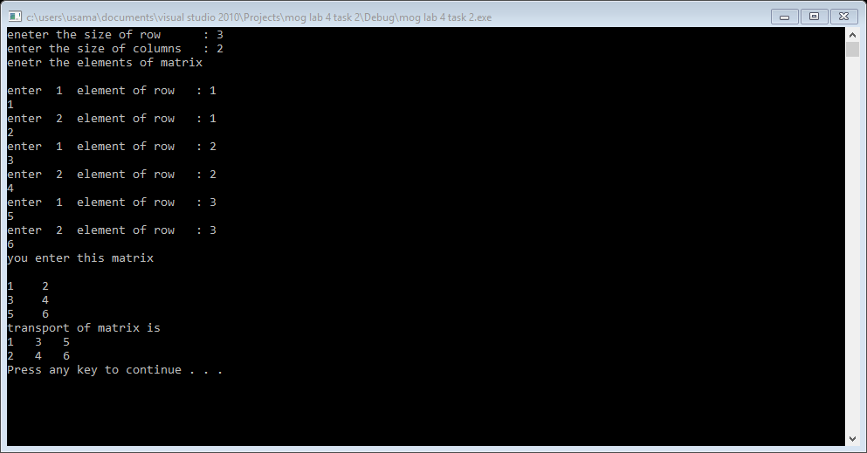

Task 3:

#include<iostream>

using namespace std;

int main()

{

char ptr[]="hello word";

int size=strlen(ptr);

for(int i=size-1; i>=0; i--)

{

cout<<*(ptr+i);

}

cout<<endl;

system("pause");

return 0;

}

Result:

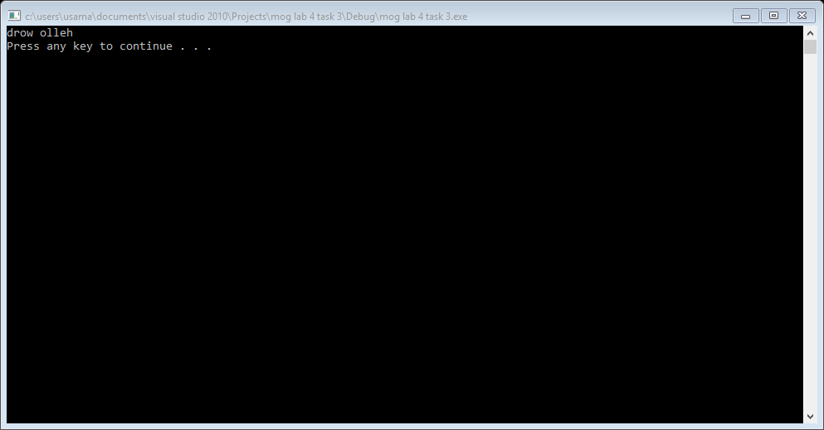

Task 4:

#include<iostream>

using namespace std;

int main()

{

int size=0;

char *ptr=NULL;

char arry[]="abcdef";

ptr=arry;

size=strlen(arry);

//it give the address

for(int i=0; i<size; i++)

{

cout<<((int*)(ptr+i));

cout<<endl;

}

cout<<endl;

system("pause");

return 0;

}

Result:

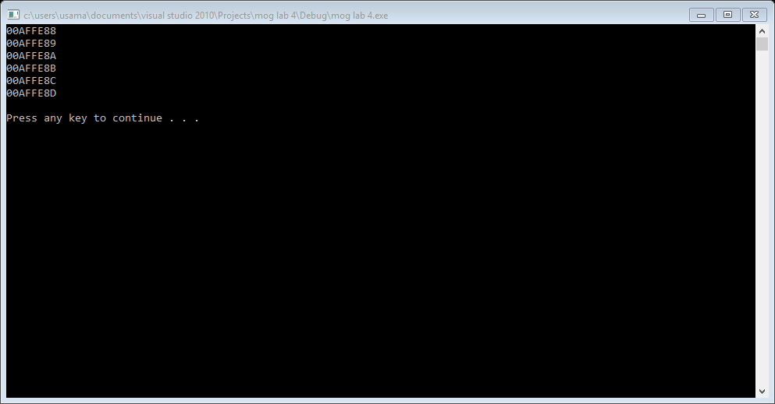

Task 5:

#include<iostream>

using namespace std;

int main()

{

int i=0;

int temp=1;

int liner=0;

int size=1;

cout<<"it break when you enter -1 "<<endl;

int *ptr=NULL;

int *ptr2=NULL;

temp=1;

ptr=new int[temp];

while(*(ptr+i)!=-1)

{

cin>>*(ptr+i);

if(*(ptr+i)!=-1)

{

i++;

temp++;

ptr2=new int[temp];

for(int j=0; j<temp-1; j++)

{

*(ptr2+j)=*(ptr+j);

}

delete[] ptr;

ptr=ptr2;

}

}

for(int j=0;j<i;j++)

cout<<ptr[j]<<" ";

cout<<liner;

system("pause");

return 0;

}